

Welcome to Sleep and TMJ Therapy! We would like to help you make the most of your visit. Included is a list of local attractions, eateries, lodging, and travel options for your convenience. Please feel free to contact us with any questions or concerns. We look forward to meeting and working with you!

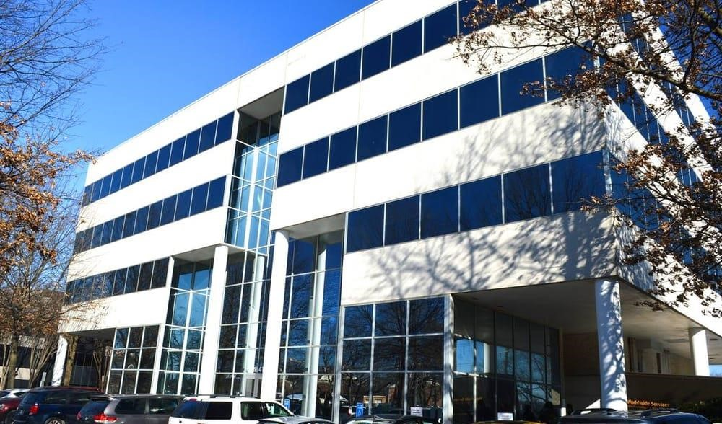

Office Information:

Address: 2841 Hartland Road Suite 301 Falls Church, VA 22043

Website: [www.sleepandtmjtherapy.com](http://www.sleepandtmjtherapy.com/)

Office number: 1(703) 821-1103

Email: Office@sleepandTMJtherapy.com Office Hours: Monday-Friday 7:00am-4:00pm; Alternating Saturdays for TMJ Massages 8:00am – 12:00pm

*\*Anything underlined can be clicked on and it will redirect you to the corresponding weblink. Enjoy!*

# TRANSPORTATION

Local Airports:

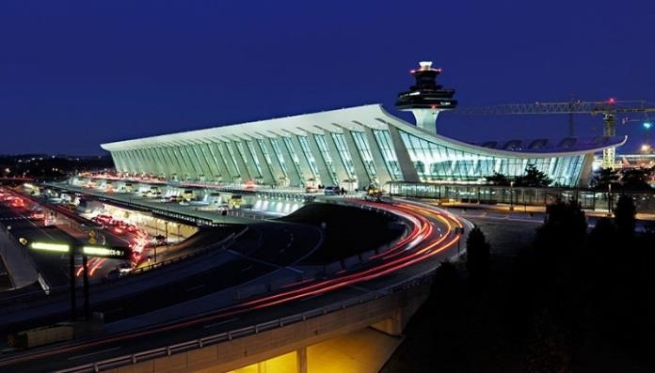

Dulles International Airport

Airport code: IAD

1 Saarinen Cir, Dulles, VA 20166 Located 20.1 miles from our office.

Ronald Reagan National Airport

Airport Code: DCA

1 Aviation Circle, Washington, DC 20001

Located 19.3 miles from our office. (Dulles International Airport)

Baltimore Washington International Airport

Airport Code: BWI

7050 Friendship Rd, Baltimore, MD 21240

Located 50.4 miles from our office.

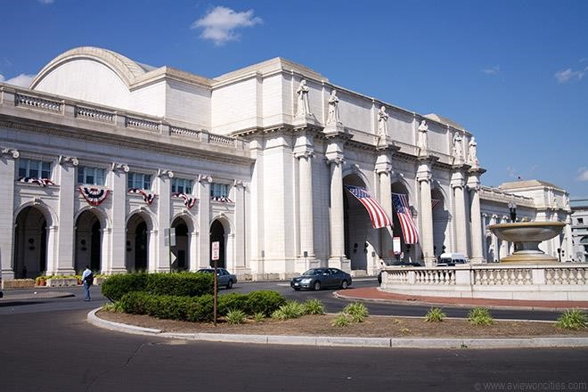

Train Stations:

[www.amtrak.com](http://www.amtrak.com)

Union Station (Train Station)

50 Massachusetts Ave NE Washington, DC 20002

Located 11.7 miles from our office.

Alexandria Union Station (Train Station)

110 Callahan Drive, Alexandria, Virginia 22314

Located 14.5 miles from our office.

(Union Station Train Station)

Local Transportation Services:

Dunn Loring Metro

2700 Gallows Rd Vienna, VA 22180

Located .8 miles from our office.

Yellow Cab Taxi

1(703) 534-1111

# TRANSPORTATION CONT…

Vienna Taxi and Airport Service

1(703) 822-4750

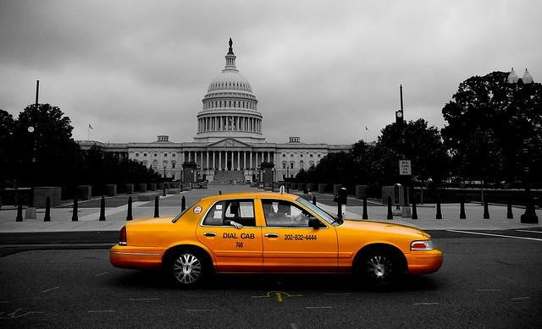

Washington Dulles Taxi

1(703) 288-3331

Enterprise Rent-a-car

1592 Spring Hill Rd Vienna, VA 22182

1(703) 356-6370

Reston Express Taxi

1(703) 402-1137 (Yellow Cab)

Instead of a taxi, use UBER

Request a ride using the app or website and get picked up within minutes.

On-demand service means no reservations, faster service, and MUCH CHEAPER!

How to use Uber:

1. Download the App on your smart phone called Uber or visit www.uber.com
2. Create an account and add your debit card to your account.
3. When you are ready to leave, type in your location and request an Uber driver.
4. Keep an eye on the map to see where your driver is. (Your driver will also call you when he/she arrives.)
5. Either enter in your destination in the app or tell the driver.
6. Once you have reached your destination, the charge will be applied to your card.
7. (No tip, cash, or credit cards will be needed.)

## *Before your first ride, use the Promo code: Megs264 to get $15 towards your first ride!*

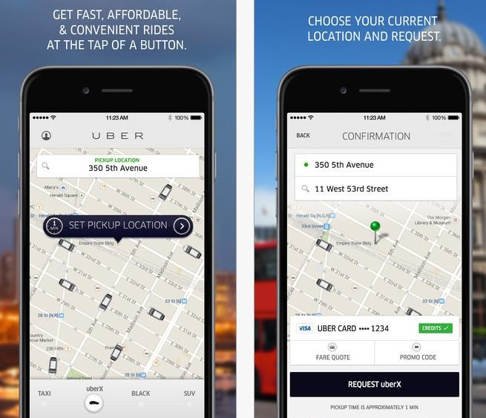

# HOTELS

[Courtyard Dunn Loring Fairfax](http://www.marriott.com/hotels/travel/iadcy-courtyard-dunn-loring-fairfax/?scid=bb1a189a-fec3-4d19-a255-54ba596febe2)

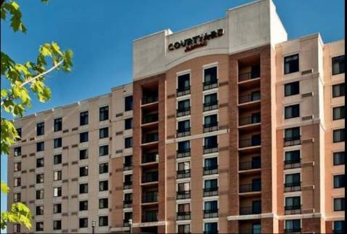

2722 Gallows Rd, Vienna, VA 22180

1(703) 573-9555

[Archer Hotel Falls Church/Merrifield](https://archerhotel.com/falls-church?utm_source=google&utm_medium=organic&utm_campaign=gmb)

8296 Glass Alley Fairfax, Virginia, USA, 22031

1(571) 327-2277

[Homewood Suites by Hilton](http://homewoodsuites3.hilton.com/en/hotels/virginia/homewood-suites-by-hilton-falls-church-i-495-rt-50-WASMFHW/index.html)

8130 Porter Road, Falls Church, Virginia, 22042 1(703) 560-6644

(Courtyard Dunn Loring Fairfax)

[Residence Inn Fairfax Merrifield](http://www.marriott.com/hotels/travel/iadxm-residence-inn-fairfax-merrifield/?scid=bb1a189a-fec3-4d19-a255-54ba596febe2)

8125 Gatehouse Rd, Falls Church, VA 22042

1(703) 573-5200

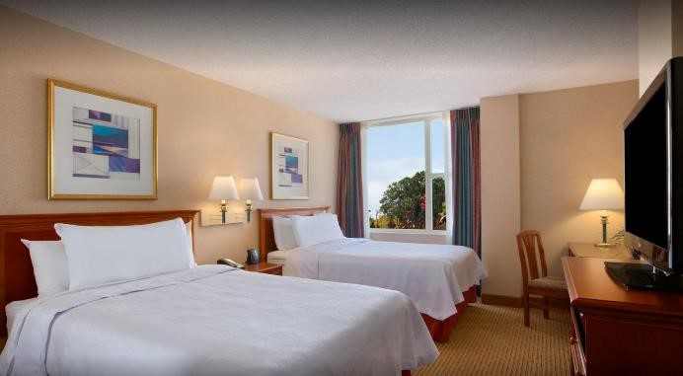

[Extended Stay America](http://www.extendedstayamerica.com/hotels/dc/washington-dc/washington-dc-falls-church-merrifield)

8281 Willow Oaks Corporate Dr, Fairfax, VA 22031

1(703) 204-0088

[Budget Inn Falls Church](https://budgetinnva.com/)

7155 Lee Highway Falls Church, VA 22046

1(703) 533-8600

[Best Western](https://www.bestwestern.com/en_US/book/hotel-details.09006.html?iata=00171880&ssob=BLBWI0004G&cid=BLBWI0004G:google:gmb:09006)

6633 Arlington Boulevard Falls Church, Virginia 22042 (Homewood Suites by Hilton)

1(703)532-9000

# HOTELS CONT…

[Hilton Garden Inn](http://hiltongardeninn3.hilton.com/en/hotels/virginia/hilton-garden-inn-falls-church-DCAFCGI/index.html)

706 West Broad Street, Falls Church, Virginia, 22046

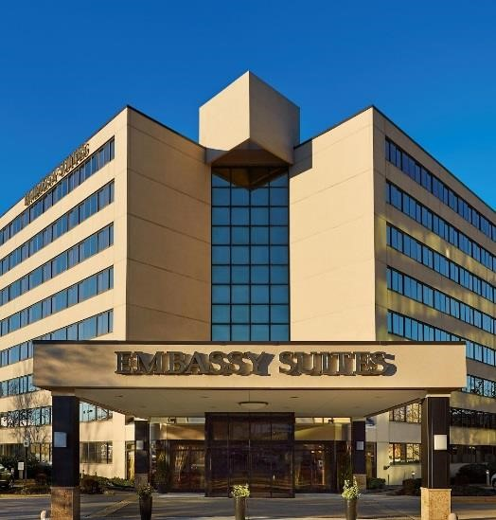

1(703) 237-8700

[TownePlace Suites](http://www.marriott.com/hotels/travel/wasts-towneplace-suites-falls-church/?scid=bb1a189a-fec3-4d19-a255-54ba596febe2)

205 Hillwood Ave, Falls Church, VA 22046

1(703)237-6172

[Embassy Suites](http://embassysuites3.hilton.com/en/hotels/virginia/embassy-suites-by-hilton-tysons-corner-WASTSES/index.html)

8517 Leesburg Pike, Vienna, VA 22182

1(703) 883-0707

[Comfort Inn](http://www.comfortinnfallschurch.com/)

6111 Arlington Blvd, Falls Church, VA 22044

1(703) 534-9100 (Embassy Suites)

*\* Hotels listed are no further than 6 miles from our office.*

# ENTERTAINMENT

[Tyson's Corner Shopping Center](http://tysonscornercenter.com/)

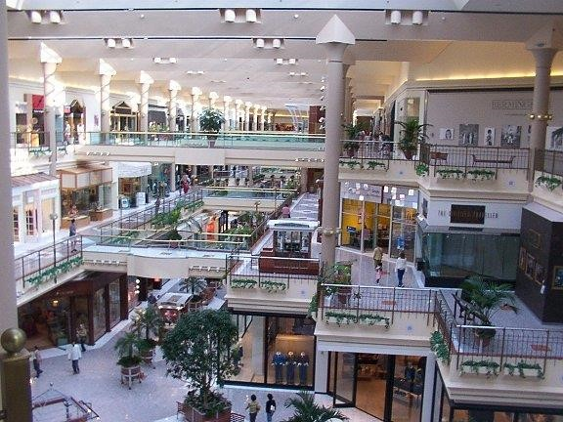

[1961 Chain Bridge Rd Ste 105, Mc Lean, VA 22102](http://www.bing.com/maps/default.aspx?cp=38.91937~-77.22623&where1=Tysons%20Corner%20Center&ss=ypid.YN873x131691543&FORM=SNAPST)

[Reston Zoo](http://www.restonzoo.com/)

1228 Hunter Mill Rd Vienna, VA 22182

1(703) 757-6222

[Washington National Zoo](http://nationalzoo.si.edu/)

Connecticut Ave NW, Washington, DC 20008

[Meadowlark Botanical Gardens](http://www.nvrpa.org/park/meadowlark_botanical_gardens/)

9750 Meadowlark Gardens Ct Vienna, VA 22182

1(703) 255-3631 (Tysons Corner Shopping Center)

# ENTERTAINMENT CONT….

[Uncork'd (Painting and Beverages)](http://www.uncorkdart.com/)

1834 Columbia Rd. 3rd Floor Washington, DC 20009



1(888) 317-1047

[Woody's Golf Range](http://woodysgolf.com/home)

11801 Leesburg Pike Herndon, VA 20170

1(703) 430-8337

[AMC Tyson's Corner (Movie Theater)](http://www.movietickets.com/theater/hid/9803/n/AMC-Tysons-Corner-16)

7850 Tysons Corner Center McLean, VA 22102

1(703) 734-6212

[Tyson's Galleria (Shopping and Dining)](http://www.tysonsgalleria.com/)

(Washington National Zoo)2001 International Drive McLean, VA 22102

1(703) 827-7730

[Ultra-Zone Laser Tag](http://www.ultralasertag.com/)

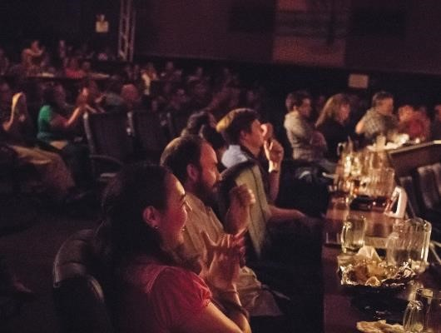

3447 Carlin Springs Rd Falls Church, VA 22041

1(703) 578-6000

[Chuck E. Cheese](http://www.chuckecheese.com/)

9404 Main St, Fairfax, VA 22031

1(703) 978-5755

[Arlington Draft House](http://arlingtondrafthouse.com/drafthouse/)

2903 Columbia Pike Arlington, VA 22204

1(703) 486-2345

[Bowl America Website](http://bowl-america.com/)  (Arlington Draft House)

9699 [Fairfax Blvd, Fairfax, VA 22031](http://www.bing.com/maps/default.aspx?cp=38.86414~-77.27895&where1=Bowl%20America&ss=ypid.YN885x41976258&FORM=SNAPST)

1(703) 273-7700

# ENTERTAINMENT CONT…

[National History Museum](http://www.amnh.org/)

10th St. & Constitution Ave., NW, Washington, D.C., 20560

[Mosaic District (Shopping and Dining)](http://mosaicdistrict.com/)

)

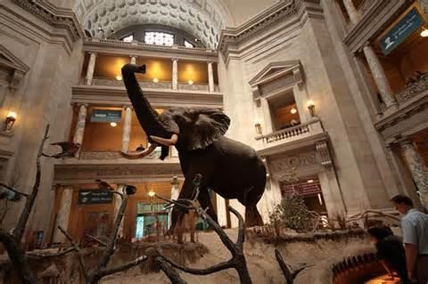

2905 District Ave, Fairfax, VA 22031

[National Aquarium](http://www.aqua.org/)

Baltimore Inner Harbor, Baltimore, MD 21202

[Top Golf](http://topgolf.com/us/)

6625 S Van Dorn St Alexandria, VA 22315

1(703) 924-2600

[Clemyjontri Park](http://www.fairfaxcounty.gov/parks/clemyjontri/)

6317 Georgetown Pike Mclean, VA 22101

1(703) 388-2807 (National History Museum )

[iFLY Loundoun (Indoor Sky Diving)](https://www.iflyworld.com/loudoun/)

20315 Commonwealth Center Drive Ashburn, VA 20315

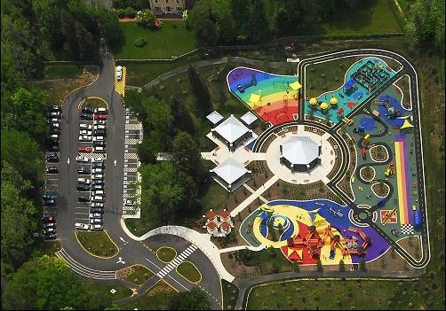

1(571) 446-4359

[National Air and Space Museum](https://www.si.edu/Museums/air-and-space-museum)

Independence Ave. at 6th St SW Washington, DC 20560

1(202) 633-2214

[National Portrait Gallery](https://www.si.edu/Museums/portrait-gallery)

8th and F St. NW Washington, DC 20560

[National Museum of African American History](https://www.si.edu/Museums/african-american-history-and-culture-museum)

15th and Constitution Ave. NW Washington, DC 20560

(Clemyjontri Park)

[National Museum of the American Indian](https://www.si.edu/Museums/american-indian-museum)

4th St. and Independence Ave. SW Washington, DC 20560

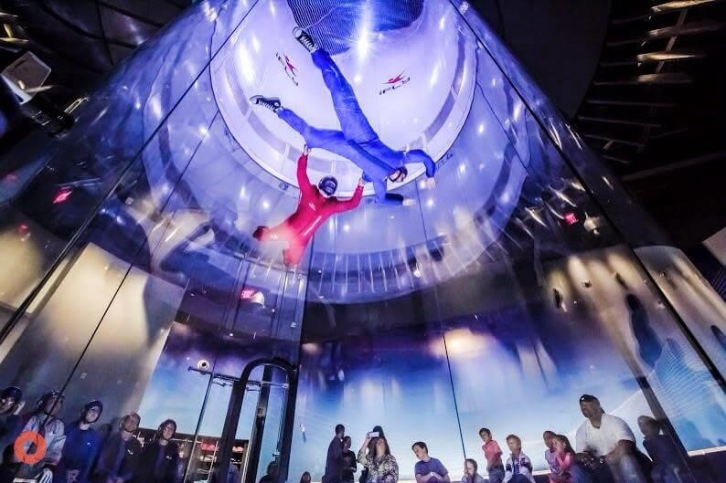

[Renwick Gallery](https://www.si.edu/Museums/renwick-gallery)

1661 Pennsylvania Ave. NW Washington, DC 20560

[Hirshhorn Museum and Sculpture Garden](https://www.si.edu/Museums/hirshhorn-museum-and-sculpture-garden)

Independence Ave. at 7th St. SW

Washington, DC 20560

[George Washington's Mount Vernon](https://www.tripadvisor.com/Attraction_Review-g57996-d104407-Reviews-George_Washington_s_Mount_Vernon-Mount_Vernon_Fairfax_County_Virginia.html)

3200 Mount Vernon Memorial Highway,

Mount Vernon, VA 22121

(iFLY Indoor Sky Diving)

# OTHER INFORMATION

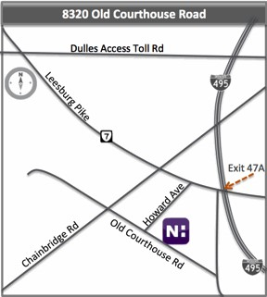

[Novant Health Imaging](http://novanthealthimaging.com/locations/virginia/novant-health-imaging-tysons-corner/)

8320 Old Courthouse Rd. Suite 130, Vienna VA 22182

Phone: 1(703)281-0213

Fax: (703)356-4602

Located 3.3 miles from our office.

Directions from I-495: Take exit 47-A for Tyson’s Corner

Route 7 West. At second light, make a left on Gallows

Road. At second light, make a right on Old Courthouse Road. Turn Right into the building parking lot, 8320 Old Courthouse Road, Tycon One Building, Suite 130.

Directions from I-66/Curtis Memorial Pkwy West: Take exit 66B, take ramp to Leesburg Pike, turn left onto Gallows Road, turn Right into parking lot, 8320 Old Courthouse Road, Tycon One Building, Suite 130.